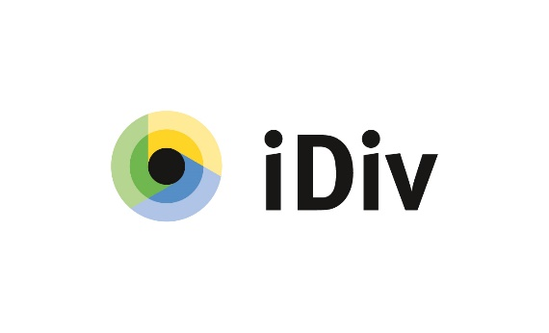
Call for proposals for the iDiv ‘Seed Fund’
2024 – 2025

<Project title>

<Applicants’ and co-applicants’ names>
<Applicants’ and co-applicants’ affiliations>
<Keywords (max. 5)>
<Date of submission>
***General comments on the template for proposals***
Proposals should be limited to 6 pages in total. Please use Verdana 10 pt font and 1.2 line spacing for the text; for tables, other font sizes and line spacing are acceptable. Proposals not fulfilling these formal criteria will not be considered.

1. Description of the project
<Please provide a concise and comprehensive description of your project, including the expected output.>

2. Contribution to the aims of the call
<Please explain how the proposal fulfills the criteria of this call, in particular with regard to a) supporting iDiv’s missions, b) its levearge effect (additional 3rd party funding) or impact on visibility, and c) strengthening the integration among iDiv members.>

3. Expenses
<Please list the estimated expenses for the project and give a brief justification for staff, consumables, travel, and other costs.>
Table: Requested funding
 | 2024 | 2025 | SUM
Staff
Consumables
Travel
<other>
Total [k€]
Note that catering and basic equipment (e.g. office supplies, IT supplies) can NOT be funded.

4. Participants:
<Please list researchers who will assume significant project responsibility and list their project contributions.>
- Main PI:
- Co-PI(s):
- Collaborators:

5. Other activities
<Please list all activities (e.g., projects, workshops, etc.) by the applicants that are related to this proposal.>

6. Bibliography (max. 15 references)
<if applicable>

